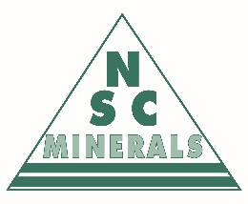

NSC Minerals Ltd.

Request Form for Donation or Sponsorship

- The NSC Minerals Corporate Giving Committee will approve donations or sponsorship for eligible groups or events in accordance with the NSC Minerals Corporate Giving Policy
- Completed applications are to be returned to nsc@nscminerals.com to the attention of the NSC Minerals Corporate Giving Committee
- Questions or comments can be directed to nsc@nscminerals.com or phone 306-934-6477

Name of Community Group or Charity (Recipient of Funds) Click or tap here to enter text.
Contact Name Click or tap here to enter text. Contact Phone Click or tap here to enter text.
Contact Email Click or tap here to enter text.
Relationship to NSC ☐Customer ☐Employee ☐Carrier/Supplier ☐Other Click or tap here to enter text.

Name of Event (if applicable) Click or tap here to enter text.
Event Location Click or tap here to enter text. Event Date Click or tap to enter a date.

Type of Support Requested Choose an item. Amount Requested Click or tap here to enter text.

Description of Event, Group, or Charity (include details regarding how the funds or promo items will be used):
Click or tap here to enter text.

Additional Comments:
Click or tap here to enter text.

For Office Use Only
Approved By: Click or tap here to enter text.
Date: Click or tap to enter a date.

